**LAB ASSIGNMENT-6**

M.Jihvitha

AP22110010330

CSE-F

**1 (a) Write a program in assembly language to print single character on screen.**

org 100h ; Set program origin for COM file

; Move the character 'S' into DL

mov dl, 'S' ; Character to be printed

; Set AH to 02h (function for displaying character)

mov ah, 02h ; DOS interrupt function to print a character

; Call the interrupt to print the character

int 21h ; Interrupt to print the character

; Terminate the program

mov ah, 4Ch ; DOS interrupt function to exit program

int 21h ; Terminate the program

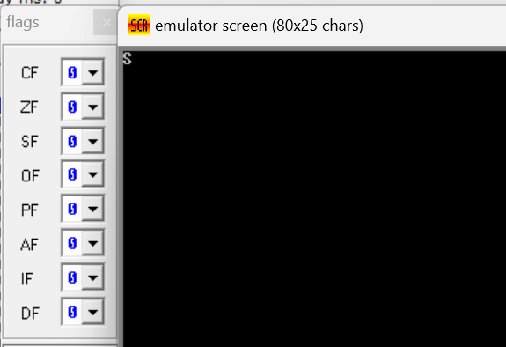

**1(b). Write an assembly language program to convert an upper-case letter to the**

**corresponding lower-case letter.**

org 100h ; Set program origin for COM file

; Load the upper-case letter 'S' into AL

mov al, 'S' ; Upper-case letter to convert

; Convert to lower-case by adding 32 (20h)

add al, 20h ; Add 32 to ASCII value

; Store the result in DL to print

mov dl, al ; Move the lower-case character into DL

; Set AH to 02h (function for displaying character)

mov ah, 02h ; DOS interrupt function to print a character

; Call the interrupt to print the character

int 21h ; Interrupt to print the character

; Terminate the program

mov ah, 4Ch ; DOS interrupt function to exit program

int 21h ; Terminate the program

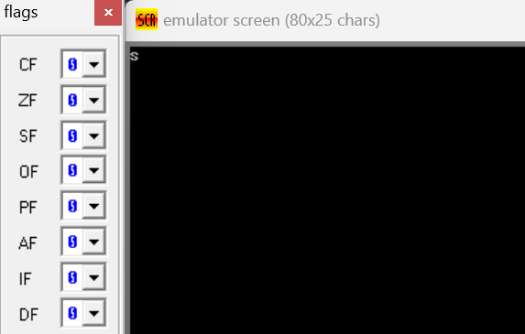

**2. (a) Write a program in assembly language to print multiple characters on screen.**

org 100h

jmp start

msg: db "COA", 0Dh, 0Ah, 24h

start: mov dx, msg ; Load the effective address of msg into DX

mov ah, 09h ; DOS function to display string

int 21h ; Call DOS interrupt to print the string

mov ah, 0 ; Prepare for keyboard input

int 16h ; Wait for a key press

ret

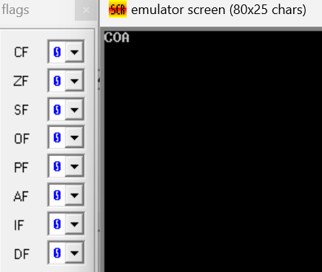

**2.(b) Write an assembly language program to convert a lower-case letter to the**

**corresponding upper-case letter.**

org 100h ; Set program origin for COM file

; Load the lower-case letter into AL

mov al,'s' ; Lower-case letter to convert

; Convert to upper-case by subtracting 32 (20h)

sub al,20h ; Subtract 32 to get the corresponding upper-case letter

; Store the result in DL to print

mov dl,al ; Move the upper-case character into DL

; Set AH to 02h (function for displaying character)

mov ah,02h ; DOS interrupt function to print a character

; Call the interrupt to print the character

int 21h ; Interrupt to print the character

; Terminate the program

mov ah,4Ch ; DOS interrupt function to exit program

int 21h ; Terminate the program

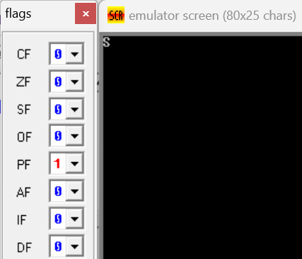

GitHub Link: